Step no 1. Go to search bar and type kubernetes services and select it

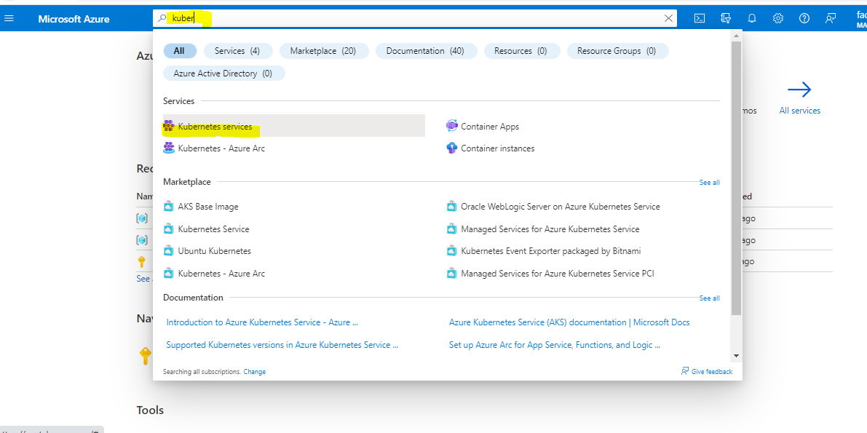

Step no 2.Click +create button and select kubernetes cluster

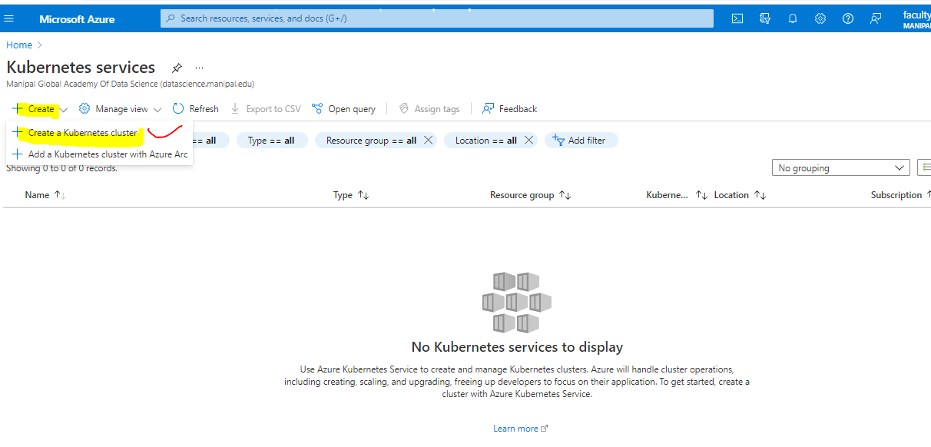

Step no 3.Create resource group and give name to cluster

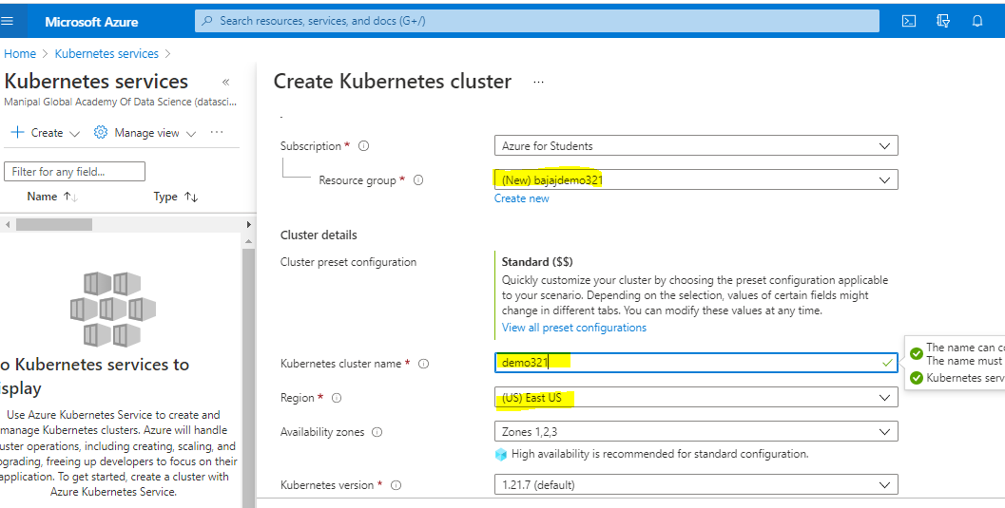

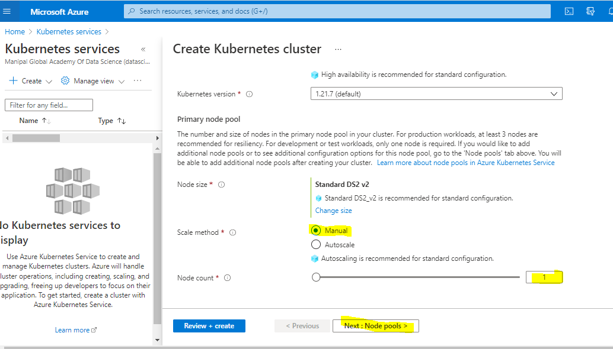

Step no 4: No need to change anything directly click review+create

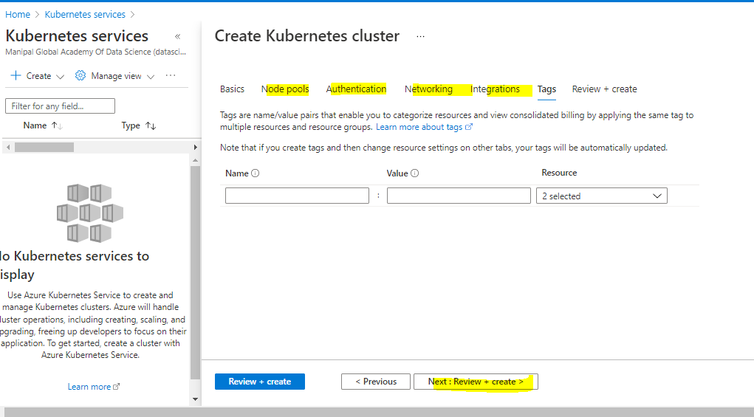

Step no 6.After validation passed click on create

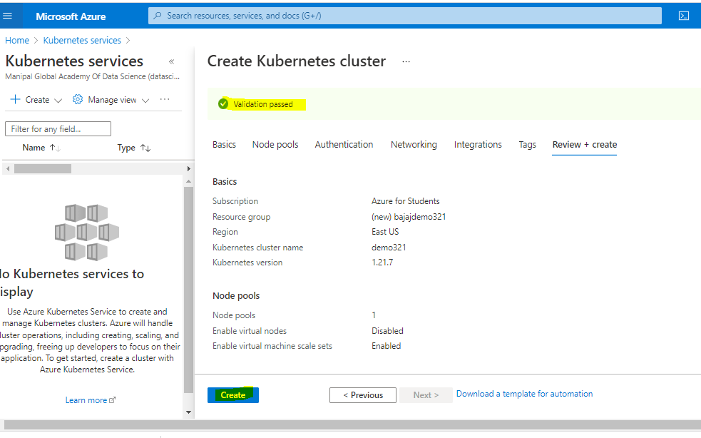

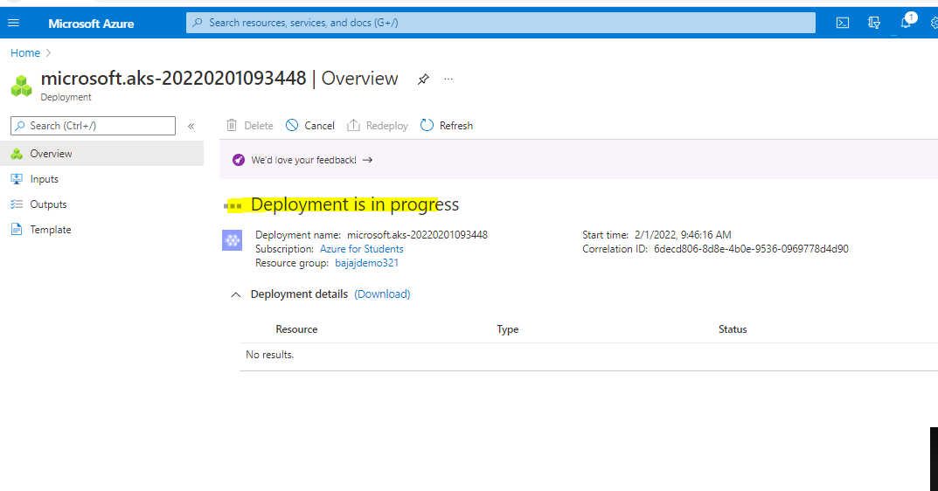

Step no 7.After deployment completion click on go to resource then click on azure cli(command line interface)

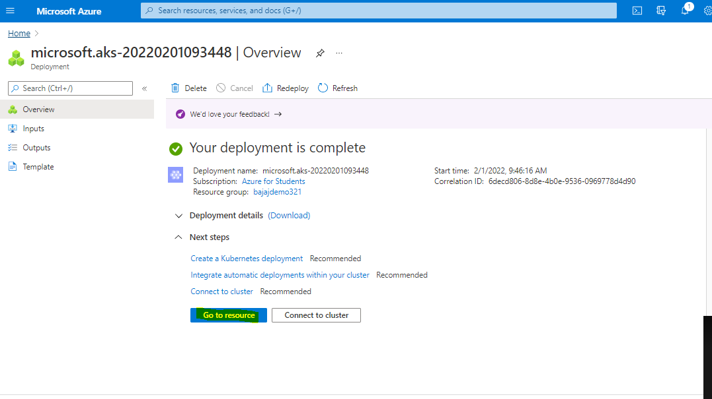

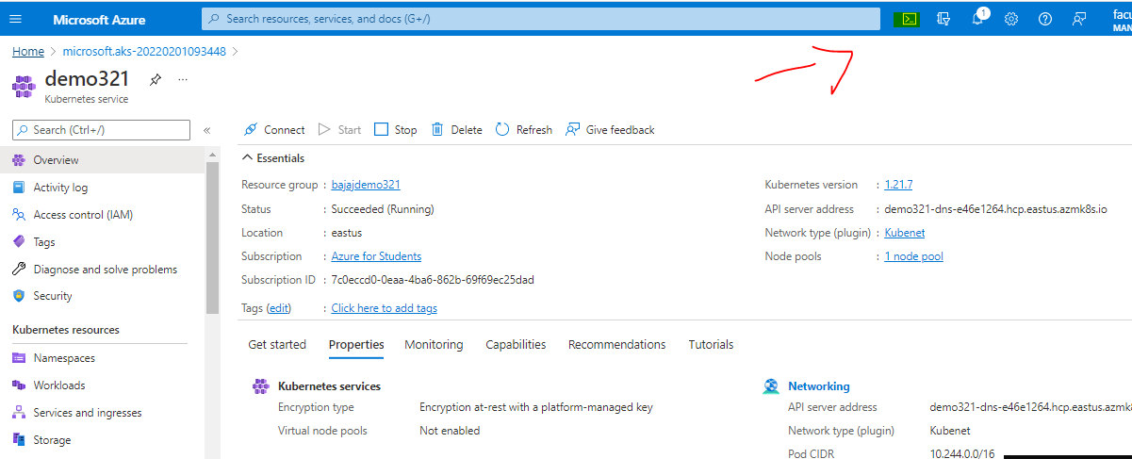

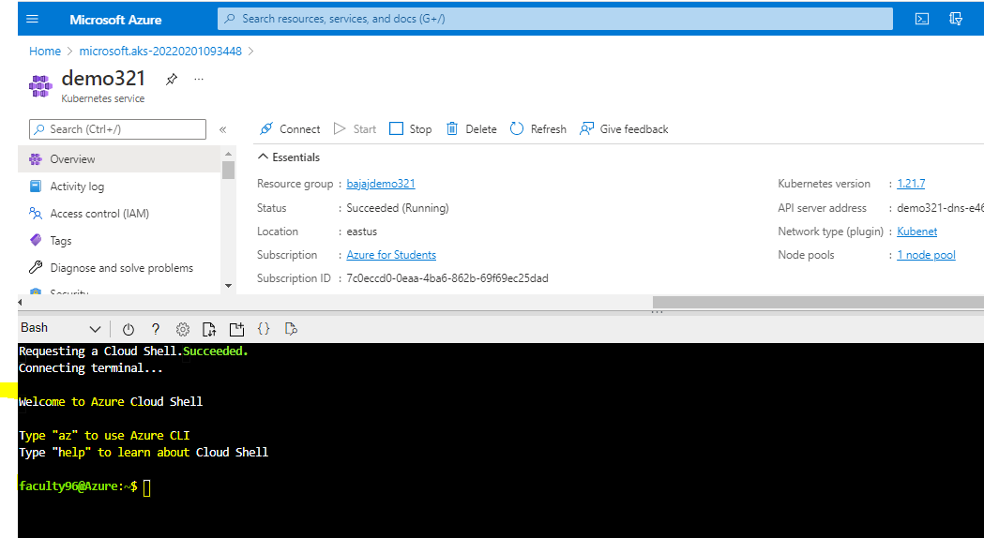

Step no 8: Configure kubectl to connect to your Kubernetes cluster using the [az aks get-credentials](https://docs.microsoft.com/en-us/cli/azure/aks#az_aks_get_credentials) command.

Cmmand: az aks get-credentials --resource-group bajajdemo321 --name demo321



Step no 9: Verify the connection to your cluster using kubectl get to return a list of the cluster nodes.

Command: kubectl get nodes



Step no 10:to run application In the Cloud Shell, use an editor to create a file named azure-vote.yaml, such as:

Command: vi azure-vote.yaml.

Step no 11:Write tha yaml code for azure voting app

Code:

apiVersion: apps/v1

kind: Deployment

metadata:

name: azure-vote-back

spec:

replicas: 1

selector:

matchLabels:

app: azure-vote-back

template:

metadata:

labels:

app: azure-vote-back

spec:

nodeSelector:

"kubernetes.io/os": linux

containers:

- name: azure-vote-back

image: mcr.microsoft.com/oss/bitnami/redis:6.0.8

env:

- name: ALLOW_EMPTY_PASSWORD

value: "yes"

resources:

requests:

cpu: 100m

memory: 128Mi

limits:

cpu: 250m

memory: 256Mi

ports:

- containerPort: 6379

name: redis

---

apiVersion: v1

kind: Service

metadata:

name: azure-vote-back

spec:

ports:

- port: 6379

selector:

app: azure-vote-back

---

apiVersion: apps/v1

kind: Deployment

metadata:

name: azure-vote-front

spec:

replicas: 1

selector:

matchLabels:

app: azure-vote-front

template:

metadata:

labels:

app: azure-vote-front

spec:

nodeSelector:

"kubernetes.io/os": linux

containers:

- name: azure-vote-front

image: mcr.microsoft.com/azuredocs/azure-vote-front:v1

resources:

requests:

cpu: 100m

memory: 128Mi

limits:

cpu: 250m

memory: 256Mi

ports:

- containerPort: 80

env:

- name: REDIS

value: "azure-vote-back"

---

apiVersion: v1

kind: Service

metadata:

name: azure-vote-front

spec:

type: LoadBalancer

ports:

- port: 80

selector:

app: azure-vote-front

step no 12: Deploy the application using the kubectl apply command and specify the name of your YAML manifest

Command: kubectl apply -f azure-vote.yaml.

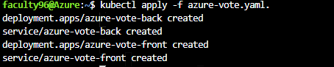

Step no 13:with the help of below command test application

Command: kubectl get service azure-vote-front –watch

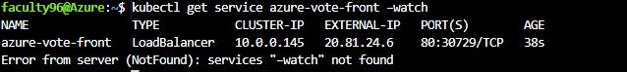

Step no 14:copy the external ip and paste in tab we are getting azure voter app

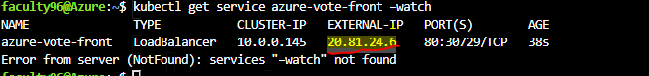

Step no 15:paste the ip in new tab

